Question 1.

Here is a plot of the graph with the data and random weights assigned to the neurons.

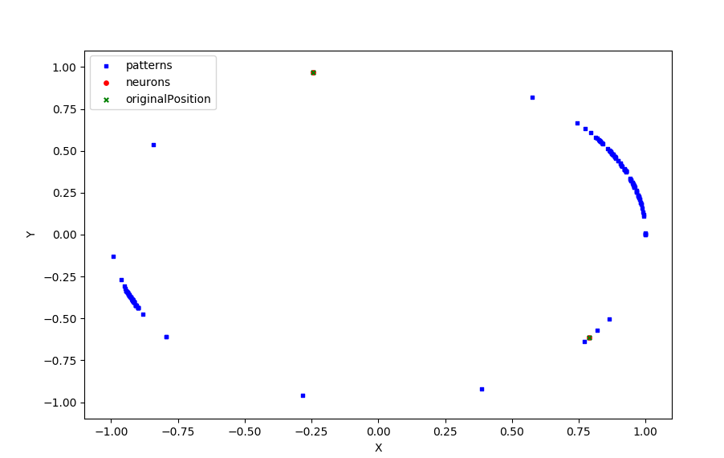

Here is a plot after the calculations are complete.

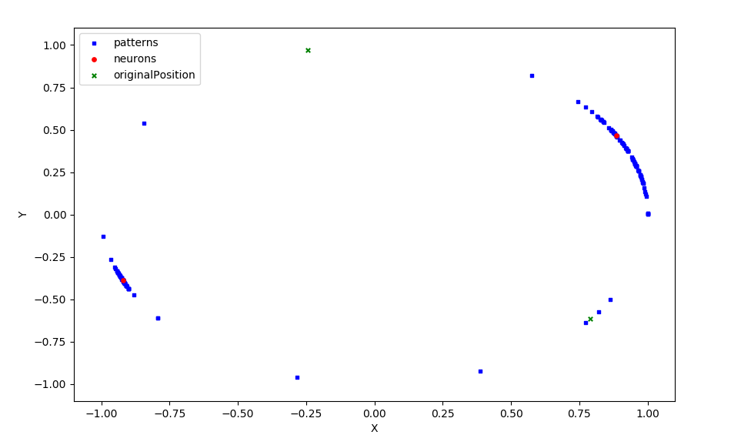

It appears that the neurons had no problems finding the clusters. This is with an alpha of 0.1 after 1 iteration. As the patterns are applied it appears one of the neurons will move for a few iterations and as it gets closer the other neuron will begin moving. So it appears there is a back and forth of each neuron moving.

Here is a plot of chosen weights.

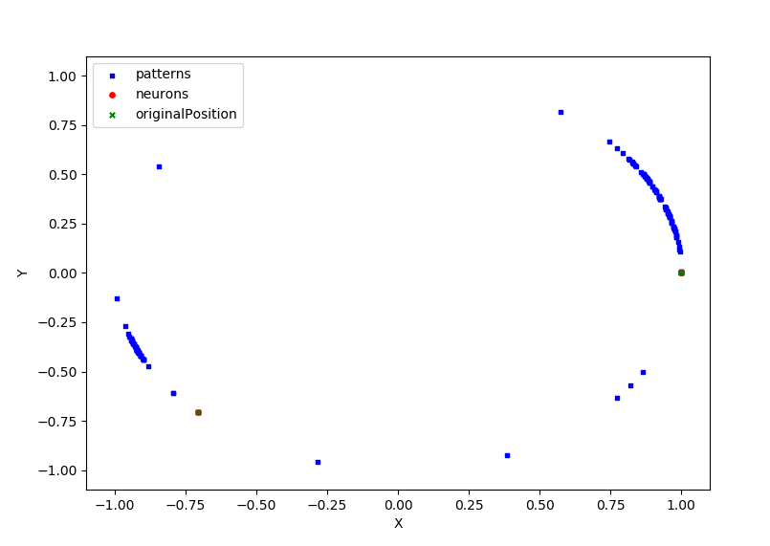

Here is a plot after they have converged.

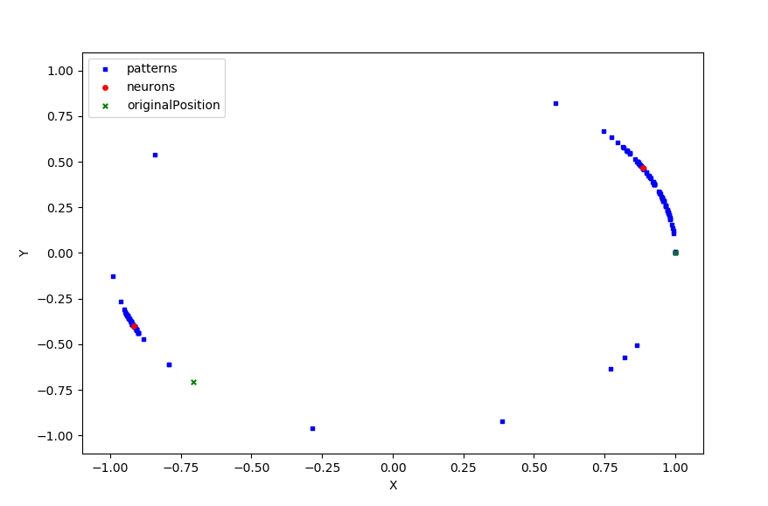

I decided to start the weights closer to the known clusters and it appeared they were able to find the clusters in one iteration. Watching the neurons move it appears one will move for about 10 steps then there will be a back and forth then one will stop moving and the other will take over. It seemed like just one iteration was enough for both the random weights and the assigned weights. Also having an alpha of 0.1 seemed to work perfectly so no adjustments were made.

Here is a plot of 3 neurons with determined weights.

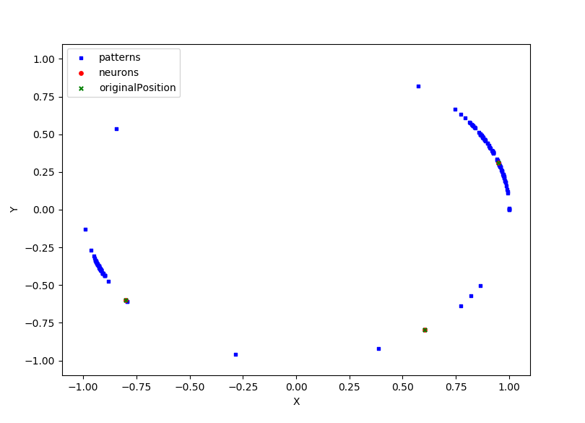

After 1 iteration.

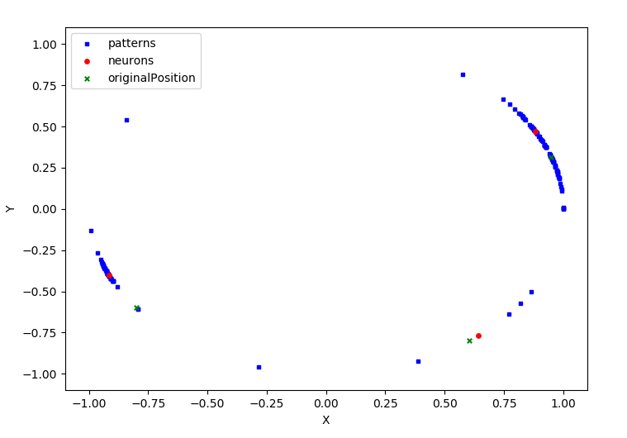

After 2 iterations.

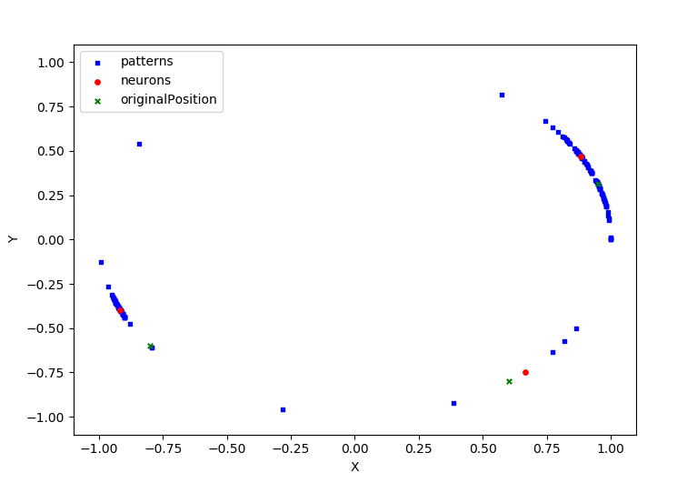

Here is a plot of 3 neurons with random determined weights.

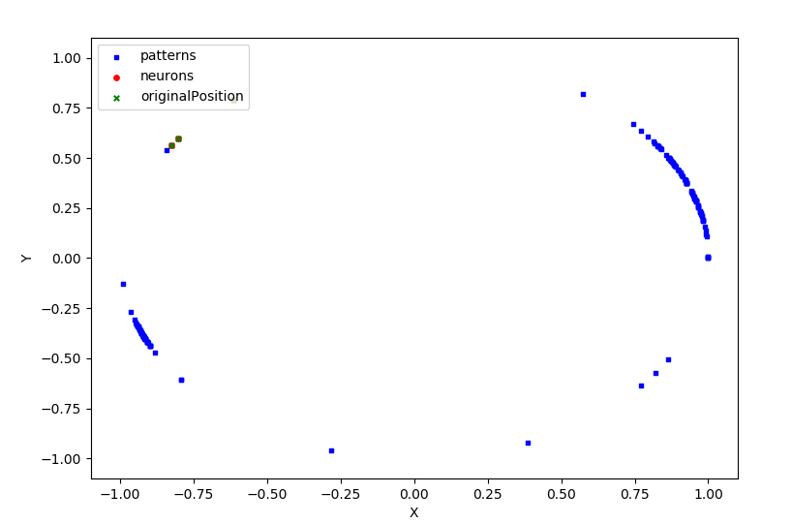

After 1 iteration.

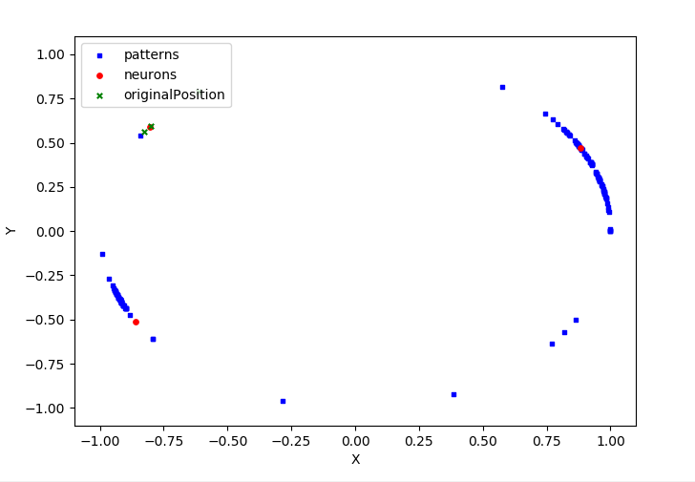

After 2 iterations.



What appears to happen here is one of the three neurons will be begin to starve. In the beginning one of the neurons will begin to move and get close to a cluster. Then a second will move towards another cluster. Then what happens is the original first will begin to move again. The third neuron will begin to gravitate towards one or two patterns that are far away from the other clusters. Sometimes a pair of neurons will share a cluster and be setup on either ends of it. For these neurons to be effective it took 2 iterations with an alpha of .01. It appeared it took a longer time for the neurons to latch onto a cluster compared to just the 2 neurons.

Here is a plot with 7 neurons,

Here is after 1 iteration.

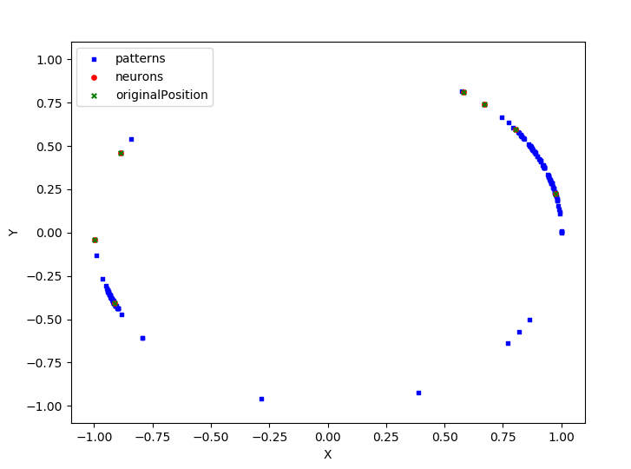

After 2.

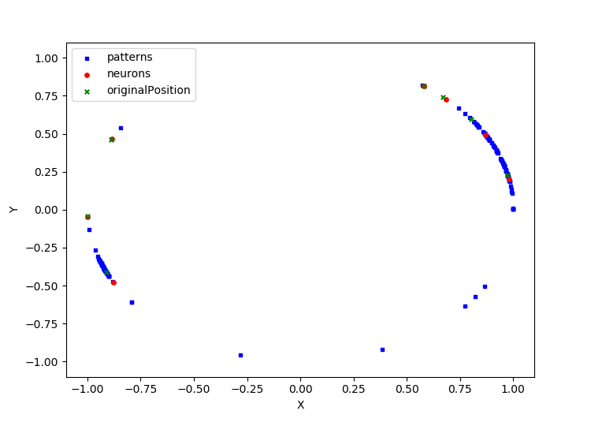

After 3.

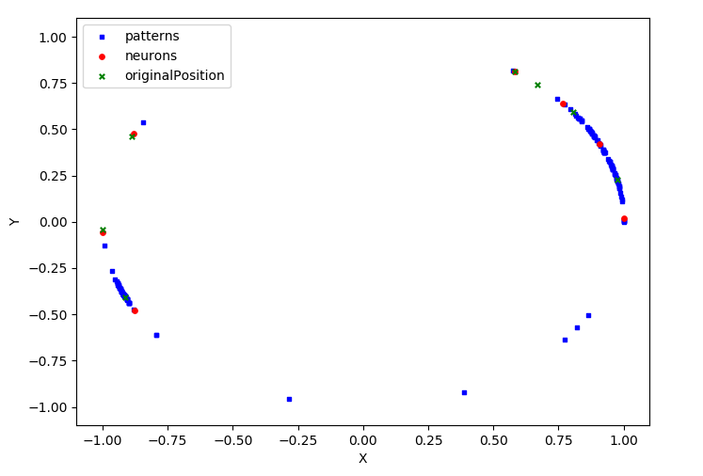

For the 7 neurons it didn’t really matter it the weights were randomized or preselected since the data only has 2 large clusters. Whether random or predetermined behaved the same way. It appeared that one of the neurons would dominate in the beginning and get very close to one cluster. Then 2 or 3 of the neurons would begin to move and one of them would pull ahead and begin winning the net value. Then another set of neurons would compete and one of them would pull ahead. This continued over the course of 3 iterations. 3 or 4 iterations seemed optimal in making sure all of the neurons had a chance to move. This is still with an alpha of .01. Once the clusters had been claimed by a few of the neurons the rest would just gravitate towards a single pattern. Sometimes if neurons spawned on either end of a cluster they would appear to share it after a couple of iterations. This is clearly too many neurons for this many patterns and clusters. It seemed like 3 neurons with predetermined positions was optimal for this data set.